Sebastian Siqueiros
Module 4.2 Assignment

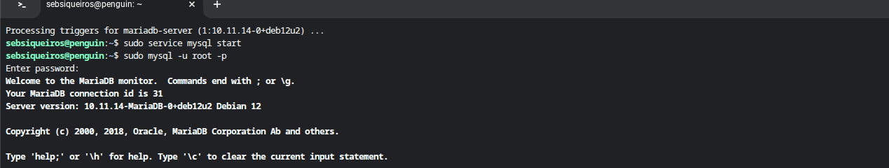

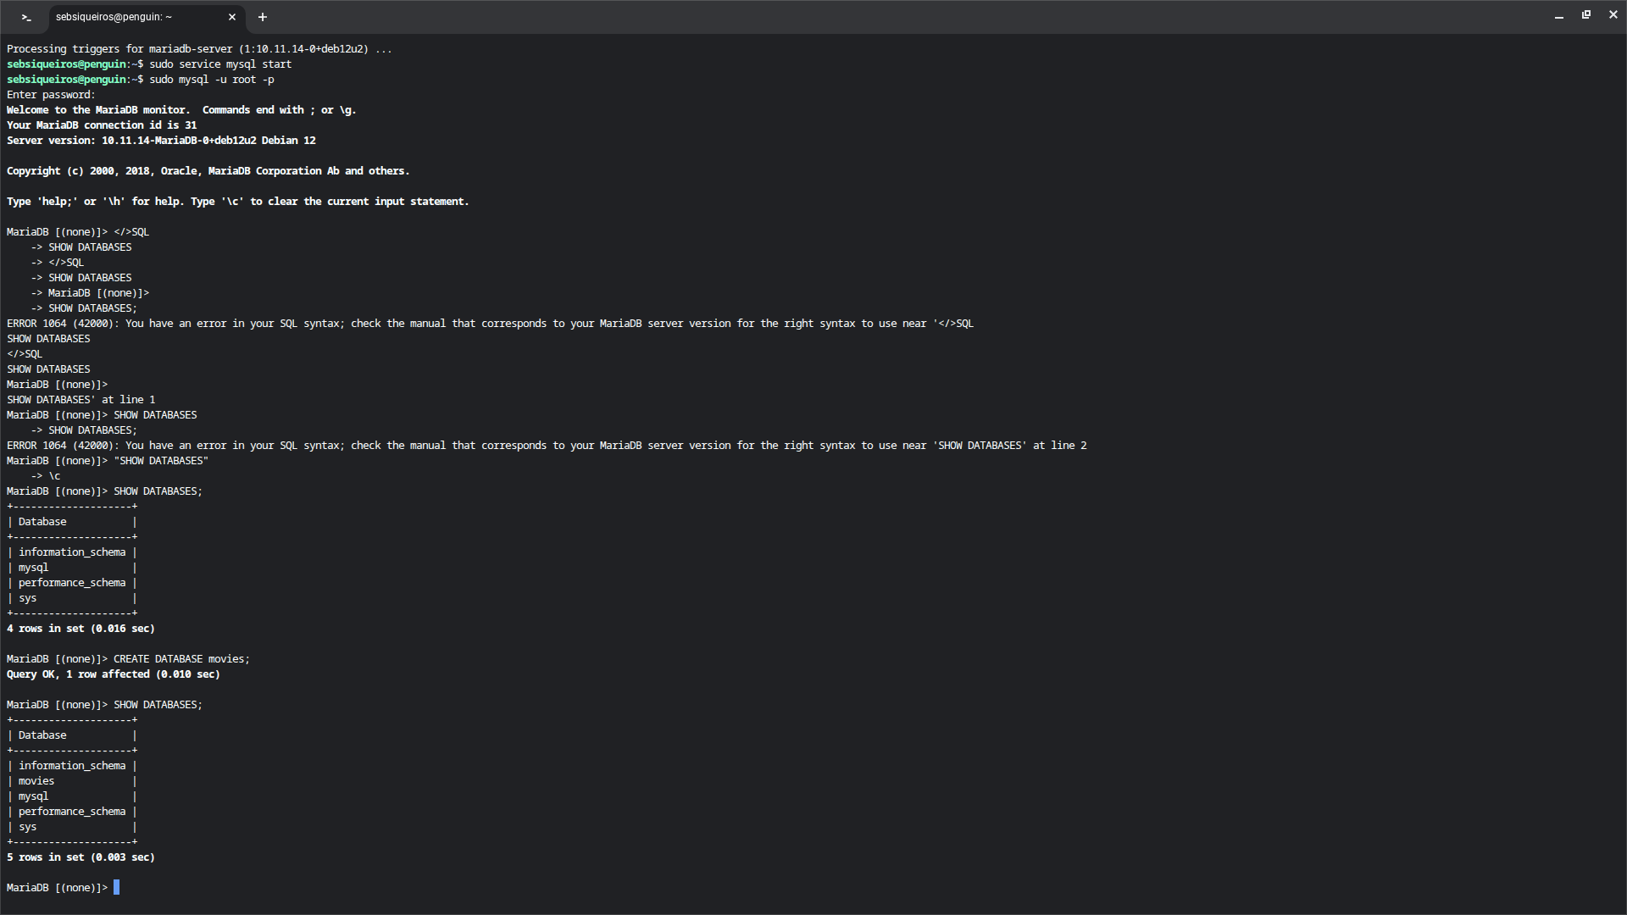

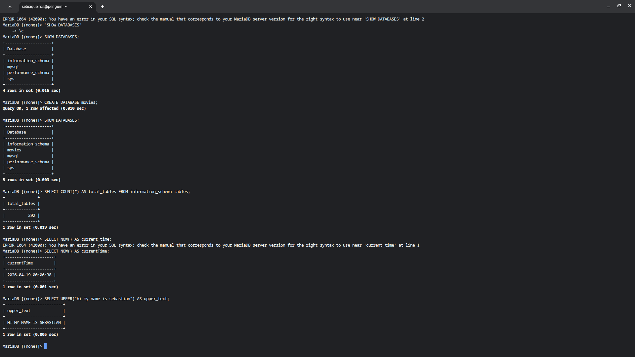

The 3 functions I used were Count(), Now(), and Upper().

Count() is used to count how many rows are in a table and can aid in documenting the number of records that exist.

Now() will return the date and time, and you can use it for tracking data creation and update times.

Upper() This converts text to uppercase and helps you format your text to what you want it to be.

